Title

A.B. Firstauthor*, C. Firstcoauthor** and D.E. Secondcoauthor*
* Department, School, University Affiliation
** Department, School, University Affiliation
e-mail: e-mail address of the first (and presenting) author

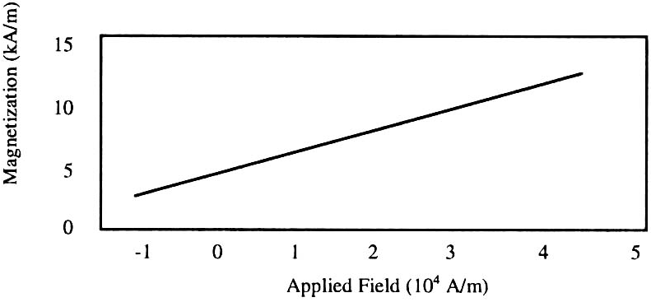
Prepare Papers in Two-Column Format for the Proceedings

Introduction
Your goal is to prepare an extended abstract for submission to the 14th Multidisciplinary International Student Workshop 2023 (MISW2023) and its publication in the conference proceedings. For additional information, please contact the following email:
miura.s.aj-misw2023@ml.m.titech.ac.jp

Full-Sized Camera-Ready (CR) Copy
Prepare your paper in full-size format on A4 paper (210 x 297 mm).
- Magnetization as a function of applied field. Note how the caption is centered in the column
Type sizes and typefaces: Follow the type sizes specified in Table I. Times New Roman is the preferred font.
Margins: top & bottom = 25 mm, left & right = 20 mm.
The column width is 82 mm (3.23 in). The space between the two columns is 6 mm (0.24 in). Paragraph indentation is 3.5 mm (0.14 in).
Left- and right-justify your columns. Use tables and figures to adjust the column length.

Pages
You are allowed only one page for your extended abstract. You can freely divide your abstract into different sections and name them as you like, as long as it fits one page.

- Type Sizes for Camera-Ready Papers
Type size (pts) | Regular | Italic
8 | References, tables, table names, figure captions, footnotes, text subscripts, and superscripts
10 | Authors’ affiliations, main text, equations, email, section titles* | Subheading
11 | Authors’ names
14 | Paper title

* Uppercase

Helpful Hints

Figures and Tables
Figure captions should be centered below the figures, and table captions should be centered above. Put units in parentheses on the figure axis labels. Please prepare your
figures with consideration of cleanliness. Color figures are acceptable. Please use shades of gray, line thickness, or dashes to compare data in line graphs. Figure label fonts should be visible (recommend: > 10-point type).

Equations
Number equations consecutively with equation numbers in parentheses flush in the right margin, as in (1). Italicize Roman symbols for quantities and variables, but not Greek symbols. Use parentheses to avoid ambiguities in denominators. Punctuate equations with commas or periods when they are part of a sentence, as in
. (1)

References
Number citations consecutively in square brackets [1]. Punctuation follows the bracket [2]. Refer simply to the reference number, as in [3].
Give all authors’ names. For paper title, capitalize the first letter of each word except for conjunctions, prepositions, and proper nouns starting in small letters.

References
- T. Koudai, O. Okayama, Proceedings of Multidisciplinary International Student Workshop, p. 1881, May 2014.
[2] K. Suzukake, J. Kougaku, Transactions of Journal of Engineering, 5, 100, 2016.

