Presentation Title

A.B. Firstauthor*, C. Coauthor** and D.E. Secondcoauthor*
* Name of Department,
e-mail: e-mail address of the first (and presenting) author
** Name of Department

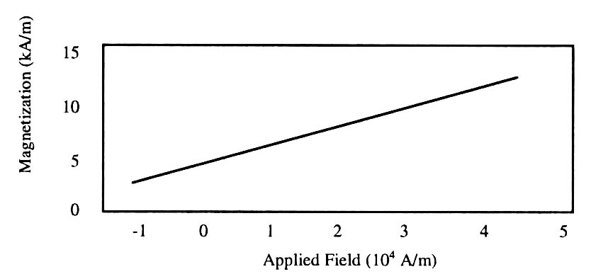
- Magnetization as a function of applied field. Note how the caption is centered in the column

Introduction
Your goal is to prepare an extended abstract for submission to the 12th Multidisciplinary International Student Workshop (MISW2021) and its publication in the proceedings. For additional information, please contact by e-mail at
okawa.s.aa-misw2021@ml.m.titech.ac.jp

Full-Sized Camera-Ready (CR) Copy
Prepare your CR paper in full-size format on A4 paper (210 x 297 mm).
Type sizes and typefaces: Follow the type sizes specified in Table I. Times New Roman is the preferred font.
Margins: top & bottom = 25 mm, left & right = 20 mm.
The column width is 82 mm (3.23 in). The space between the two columns is 6 mm (0.24 in). Paragraph indentation is 3.5 mm (0.14 in).
Left- and right-justify your columns. Use tables and figures to adjust the column length.

Pages
You are allowed only one page for your extended abstract.

Helpful Hints

Figures and Tables
Figure captions should be centered below the figures; table captions should be centered above. Put units in parentheses on the figure axis labels. Please prepare your figures with consideration of cleaness. Color figures are acceptable. Please use shades of gray, line thickness or dashes to compare data in line graphs. Figure label fonts should be > 10-point type.

Equations
- Type Sizes for Camera-Ready Papers
Type size (pts) | Regular | Italic
6 | Table captions,* table superscripts
8 | Section titles,* references, tables, table names,* first letters in table captions,* figure captions, footnotes, text subscripts, and superscripts
10 | Authors’ affiliations, main text, equations, first letters in section titles* | Subheading
11 | Authors’ names
24 | Paper title

* Uppercase
Number equations consecutively with equation numbers in parentheses flush with the right margin, as in (1). Italicize Roman symbols for quantities and variables, but not Greek symbols. Use parentheses to avoid ambiguities in denominators. Punctuate equations with commas or periods when they are part of a sentence, as in
. (1)

References
Number citations consecutively in square brackets [1]. Punctuation follows the bracket [2]. Refer simply to the reference number, as in [3].
Give all authors’ names. In a paper title, capitalize the first word and all other words except for conjunctions, prepositions less than seven letters.

References
- T. Koudai, O. Okayama, Proceedings of Multidisciplinary International Student Workshop, p. 1881, May 2014.
[2] K. Suzukake, J. Kougaku, Transactions of Journal of Engineering, 5, 100, 2016.

